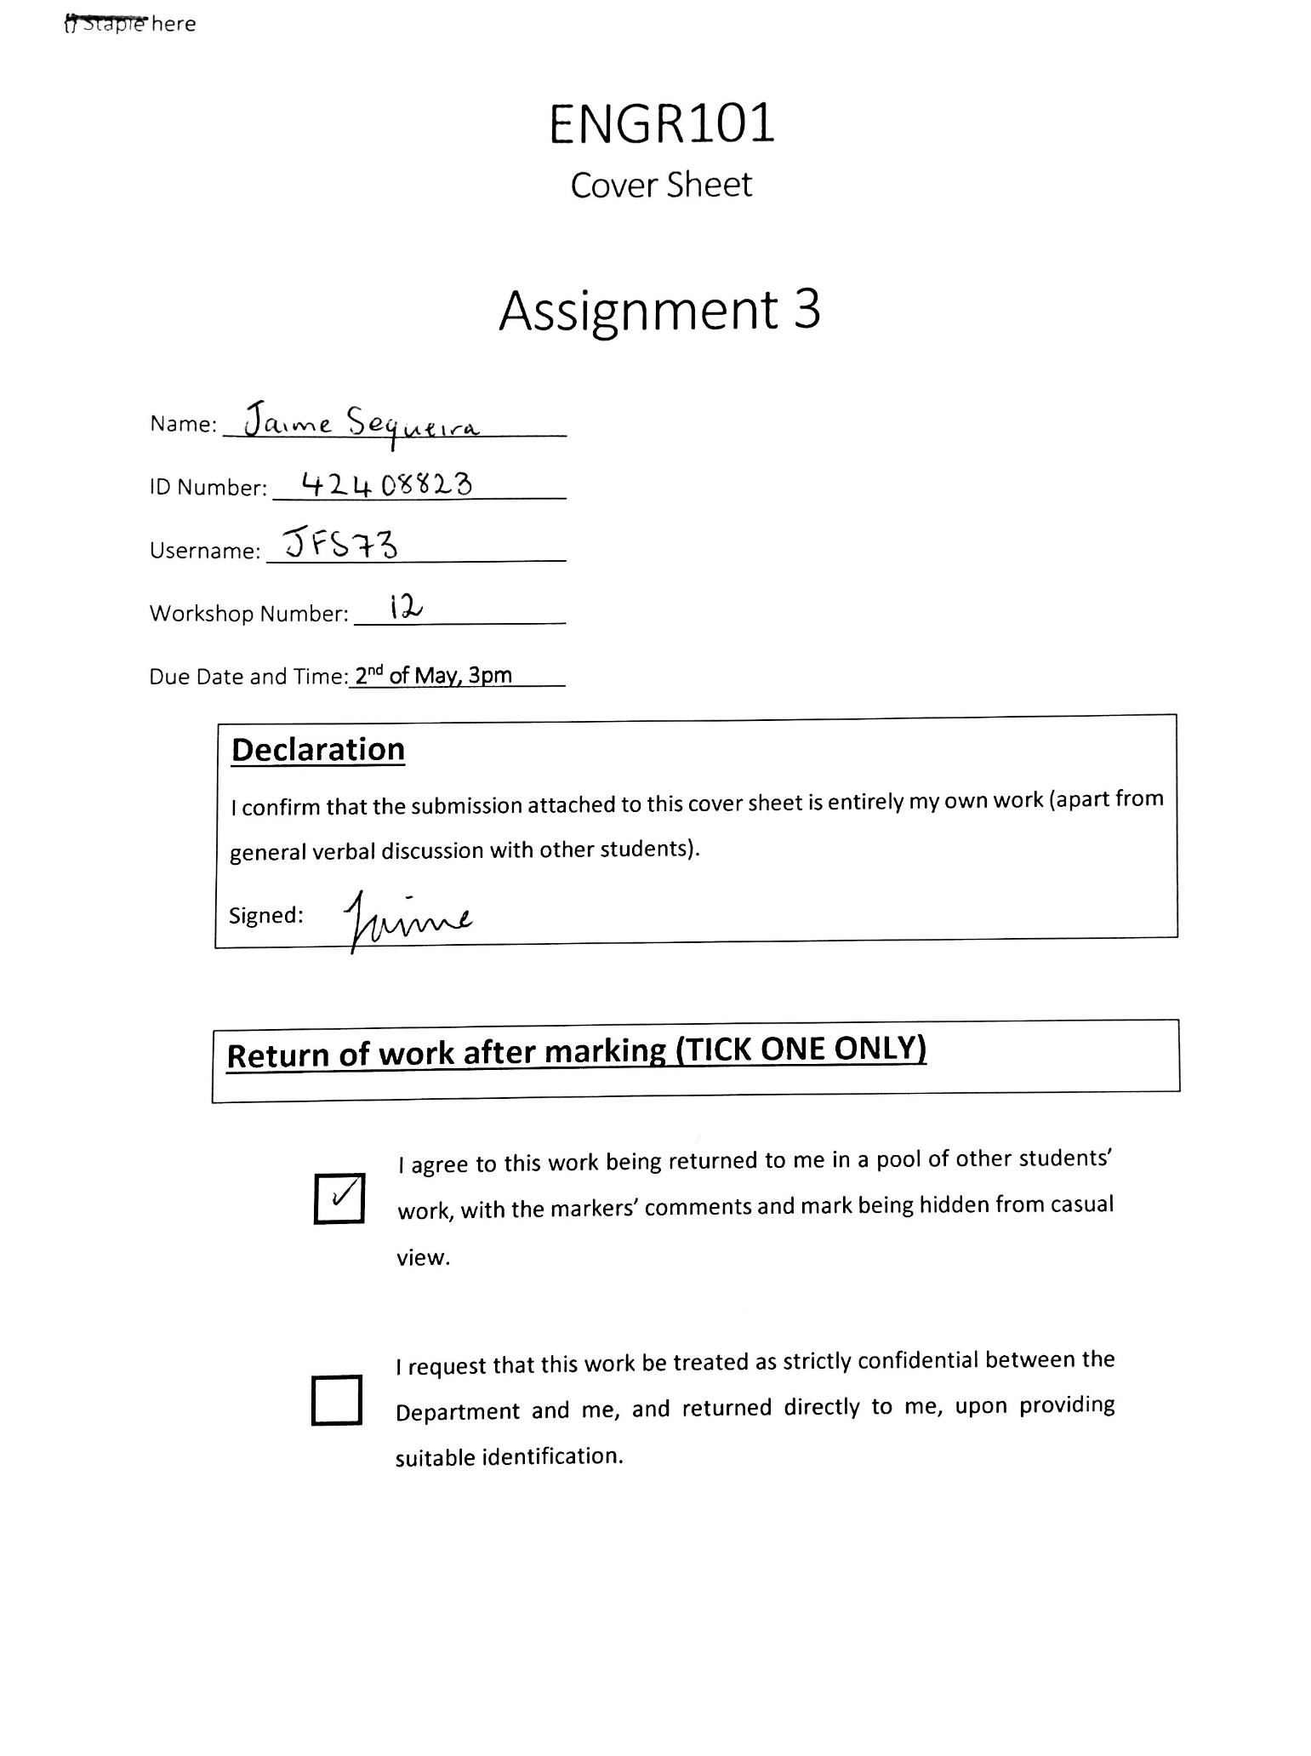ENGR101

Cover Sheet

Assignment 3

Name:

ID Number:

Username:

Workshop Number:

Due Date and Time: **2nd of May, 3pm**

**Declaration**I confirm that the submission attached to this cover sheet is entirely my own work (apart from general verbal discussion with other students).

Signed:

**Return of work after marking (TICK ONE ONLY)**

|  |  |
| --- | --- |
| **□** | I agree to this work being returned to me in a pool of other students’ work, with the markers’ comments and mark being hidden from casual view. |
| **□** | I request that this work be treated as strictly confidential between the Department and me, and returned directly to me, upon providing suitable identification. |

**Marking Schedule**

**Summary (Report Section 3)** 3 marks

Self-contained, includes objective, methodology, major results, concluding remark etc. 3

**Introduction/Background/Theory (Report Sections 5-6)** 7 marks

Identified the basic problem criteria. 2

Constraints and specifications. 1

Gathered background information from a variety of sources. Fully referenced. 4

**Experimental Methods (Report Section 7)** 5 marks

Provided at least two figures that show the testing conditions and the catapult design

with basic details and dimensions 2

Description of the model construction and testing procedure   
Must have details so it can be repeated. 3

**Results, Discussion and Conclusions (Report Sections 8-9)** 15 marks

Carried out at least one quantitative test on the model with outcomes clearly

in tabular &/or graphical form. 3

Comment on the trajectory, launching angle and the distance travelled by the payload

estimated from theory 3

Compare experimental results with the theoretical trajectories and/or distance travelled.

Discuss any differences. 4

The model was fully evaluated with reference to the design criteria. 2

Conclusions 3

**Communication and Presentation** 5 marks

Report presented concisely and clearly with good grammar. 4

All other pages, such as cover sheet, title page, table of contents, etc. are included. 1

**Penalties: exceed the page limit (> 10 pages: -1, > 12 pages: -2)**

**Total Mark /35**

Marker’s initials:

The Theory of Projective Motion Tested As An Engineer.

Jaime Sequeira

ENGR101

Foundations of Engineering

2017

University of Canterbury

# Summary

A great engineer is considered to be a person who can use their resources wisely and effectively while also completing the job within a set time-frame. This was put to the test by constructing a catapult costing less than $20. The catapult was constructed by creating a square base made from Popsicle sticks. Each side was made by gluing three Popsicle sticks together with hot glue. Vertical pillars were constructed using the same method. A spoon was placed inside a rubber band that was stretched between the two pillars. The catapult was able to launch a dice that hit a target one and two metres away. The theoretical distances calculated were +0.24 and +0.13 metres more than the experimental distances respectively. The theoretical values did not take air resistance into account.

Table of Contents

Summary i

Introduction 1

Background and Theory 1

Projectile Motion Equations 1

Linear Motion Equations 2

Constraints and criteria 2

Experimental Methods 3

Materials and Costs 3

Initial Build 3

Modifications 4

Launching the catapult 4

Results and Discussion 5

Experimental Results 5

Theoretical Results 7

Comparing theoretical and experimental values 8

Changing the launching angle 9

Conclusions 9

References 10

Appendices 11

# Introduction

A great engineer is able to use resources wisely in order to complete a job under budget and within a specific timeframe. Therefore this assignment and report focuses on how to build a catapult with limited resources and within a certain timeframe. The objective of this assignment was to construct a catapult that hit a set of specified targets while costing less than $20 to construct. This report compares the theoretical values of projective motion with the experimental values calculated after conducting experiments on the constructed catapult.

# Background and Theory

If an object was to be launched into the air and the only force acting on was gravity, the motion travelled by the object would be known as projectile motion (The Physics Classroom, 2017).

## Projectile Motion Equations

The first main equation used when dealing with projectile motion is

|  |  |  |
| --- | --- | --- |
|  |  | ( 1 ) (ENGR101S1 – Assignment 3, 2017) |

This equation was used to calculate the time that the projectile stayed above zero on the y axis. This was derived when t was the time in seconds, vo was the original velocity of the object, theta was the angle that the object was released to the horizontal and g was the acceleration of the object in the y direction due to gravity (9.81ms-2).

The next main equation used when dealing with projectile motion is

|  |  |  |
| --- | --- | --- |
|  |  | ( 2 ) (Serway, Jewett, Wilson and Wilson, 2013) |

This equation was used to calculate the maximum height that the object reached. This was derived when h was the height in metres. Vo was the original velocity of the object. Theta was the angle the object was released to the horizontal. G was the acceleration of the object in the y direction due to gravity.

The last main equation used in projectile motion problems is

|  |  |  |
| --- | --- | --- |
|  |  | ( 3 ) (Serway et al., 2013) |

This equation was used to calculate what the theoretical distance travelled by the object would be. This was derived when r was the maximum distance travelled by the object in metres (the range). Vo was the original velocity of the object (ms-1). Theta was the angle the object was released to the horizontal. G was the acceleration of the object in the y direction due to gravity.

These equations assumed that the catapult launched the projectile at the same height it landed. Therefore, in order to keep this assumption true throughout the experiment, the projectile was released at the same height of the target.

## Linear Motion Equations

The only linear motion equation that was used in this experiment and calculations was

|  |  |  |
| --- | --- | --- |
|  |  | ( 4 ) (Serway et al., 2013) |

This was used to calculate the mean velocity of the object in the x direction. This was derived when vx was the mean velocity of the object traveling in the x direction (ms-1). Sx was the distance travelled by the object (displacement) in the x direction (metres). T was the time that the object travelled in the x direction (seconds).

## Constraints and criteria

The total cost of constructing the catapult had to be less than $20.00. In addition to this, the catapult needed to launch an object and hit specified targets. The first target was one meter away horizontally from the base of the catapult and had a radius of 10cm. The second target was two meters horizontally away from the base of the catapult with a radius of 20cm.

# Experimental Methods

## Materials and Costs

The budget for creating this catapult was $20. Therefore, this build had to be constructed from cheap and easy to find materials. The best place to find cheap items was the 123 Mart and The Two Dollar shop in Northlands mall. The materials used for the build and the costs were as follows:

* Wooden Popsicle sticks - $2.50 (Purchased from the 123Mart as a packet of 100.)
* Rubber bands - $3.00 (Purchased from The Warehouse as a ball of 300 rubber bands.)
* Hot glue gun and glue - $8.00 (Purchased from The Two Dollar Shop with two sticks of glue.)
* Plastic spoon – free (found inside home)
* Dice – free (found inside home)

The total cost of the build was $13.50. This was $6.50 under the budget.

## Initial Build

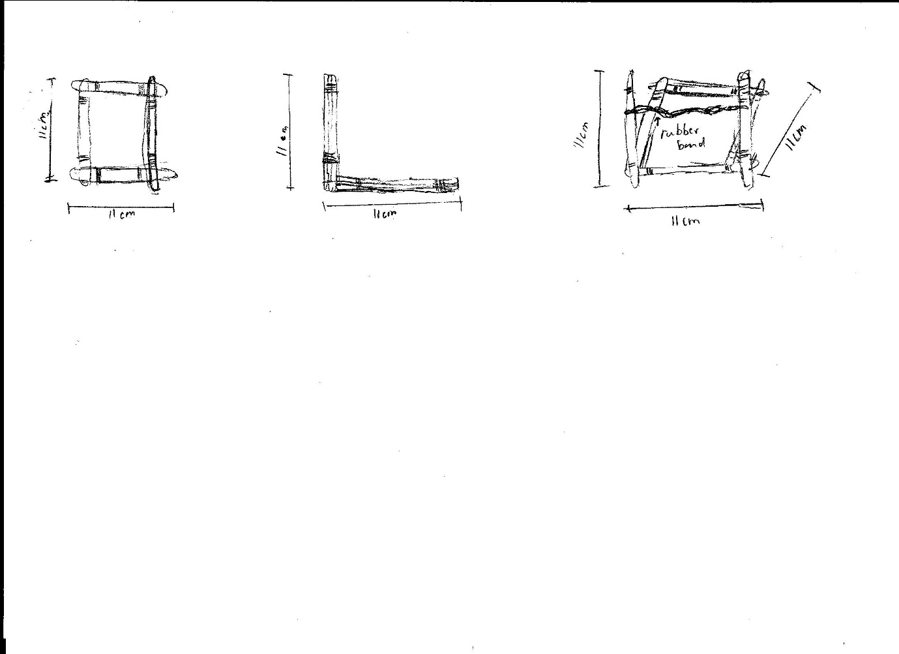The base of the catapult was formed by creating a square using the Popsicle sticks. For each side of the square, three Popsicle sticks were used to increase the rigidity. These three Popsicle sticks were held together by tying them together with the rubber bands. Each of the four corners were held together using hot glue from the hot glue gun. Next, the vertical sides of the catapult were constructed in the same manner. Both sides were constructed by tying three Popsicle sticks with rubber bands and the ends were glued with hot glue to the main structure. Finally, a rubber band was twisted four times and stretched across the two sides. This was used to place the spoon inside. This was the first build of the catapult. Free hand sketches and dimensions of the first construction are provided

Figure 3: a sketch to show the initial catapult as a whole.

Figure 2: A sketch to show the side of the initial catapult.

Figure 1: A sketch to show the initial base of the catapult.

below (not to scale).

## Modifications

One of the main issues with this first attempt was that the vertical sides of the catapult were always pulled towards the centre because they were not strong enough to withstand the force of the central rubber band. A brace in the shape of an x was used to solve this issue.

The next issue with this build was that the spoon kept slipping out of the rubber band. A wooden Popsicle stick was glued horizontally onto the front brace. This stopped the spoon from slipping out of the rubber band.

The last issue was that when the spoon was pulled back more than half way, the vertical sides started to bend backwards. This was due to them not being able to withstand the force of the rubber band. To overcome this problem, a support Popsicle stick was added to each side and stuck using the hot glue. This made the build even more rigid and stopped any form of bending in the Popsicle sticks.

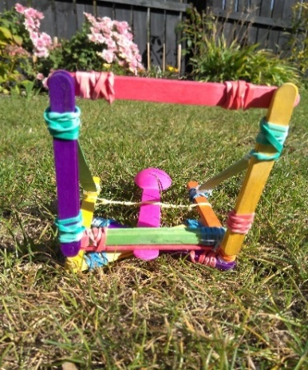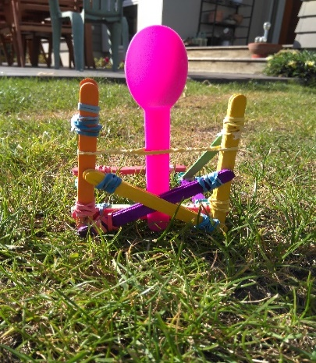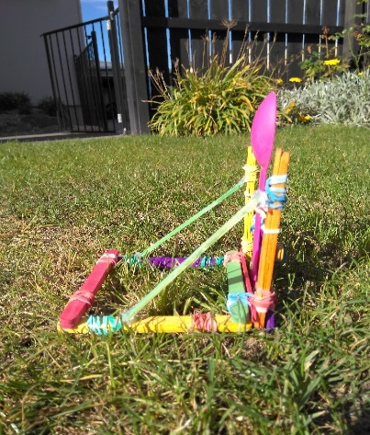After these modifications, the catapult was able to hit the desired targets. Pictures of the final build are below.

Figure 6: Front view of the catapult.

Figure 5: View from under the catapult to show the base.

Figure 4: Side view of catapult demonstrating the use of braces.

## Launching the catapult

The method to test the catapult was as follows. First, a measuring tape was extended in a straight line. This provided a way of measuring how far the dice travelled horizontally. The target was created by stacking books on top of each other until they were the same height as the point when the dice was released from the catapult. This meant that the theoretical equations of projective motion were able to be used without having to modify them for changes in height.

The catapult was tested at different angles of pull-back until the angle of pull-back was found that made the dice hit the specified target. Then when the angle was found, the experiment was recorded with a slow-motion camera. The camera recorded the distance that the dice travelled.

The experiment was also timed with a stopwatch. This was done in order to calculate the velocity of the dice which will be reported on later in the report. A more accurate method of timing the experiment would have increased the accuracy of the experiment. The dice travelled at a very fast speed and it was hard to start and stop the timer at exactly the right time. A photo of how the experiment was conducted is shown below.

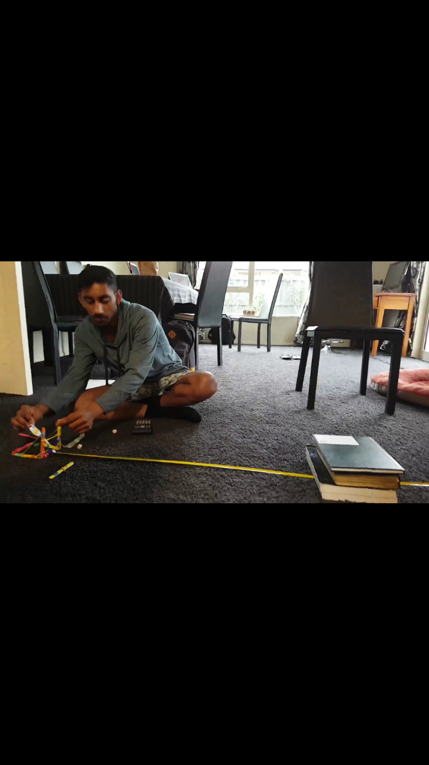

Figure 7: A visual representation of how the experiments were conducted.

# Results and Discussion

## Experimental Results

Vx was determined by using equation (4). When the dice hit the target one metre away, sx was one metre and t was 0.21 seconds. Vx was calculated to be 4.762ms^-1. When the dice hit the target two metres away, sx was two metres and t was 0.32 seconds. Vx was calculated to be 6.25ms^-1. These values were used to find the initial velocity of the dice when it was launched. This was calculated by using Pythagoras’ Theorem as can be seen below.

Vinitial (Hypotenuse)

Angle of release with respect to the horizontal (Theta)

Vy (Opposite)

Vx (Adjacent)

Figure 8: The right angled triangle used to calculate the initial velocity of the dice.

The angle of release (theta) was found by examining a slow motion video of the catapult launching the dice and a protractor was used to determine the angle. Theta was 15°.

When the dice hit target one metre away, in order to find the initial horizontal velocity, Pythagoras’ theorem was used.

= 4.9299 ms^-1

When the dice hit the target two metres away, the same equation was used.

6.470476 ms^-1

The experiment was repeated. The spoon was pulled back and released from different angles. This changed the initial velocity and therefore the distance travelled by the dice changed. The quantitative results were noted in the table below.

|  |  |
| --- | --- |
| Angle of pull back (Degrees) | Distance travelled (metres) |
| 15 | 0.6 |
| 30 | 0.75 |
| 45 | 1.25 |
| 60 | 1.60 |
| 75 | 2.65 |
| 90 | 2.85 |

Table 1: The distance travelled by the dice when the catapult was pulled back to different angles.

When the spoon was pulled further back, the distance the dice travelled increased. This was because the dice had more time to accelerate before being launched into the air by the catapult.

## Theoretical Results

**Time:**

The theoretical time that the dice spent above the x axis (positive height) was calculated using equation (1). The initial velocities used were the velocities calculated before.

|  |  |
| --- | --- |
| For target at one metre | For target at two metres |
|  |  |
|  |  |
| 0.130 seconds | 0.341 seconds |

**Maximum Height:**

The theoretical maximum height that the dice reached during the motion was calculated using equation (2).

|  |  |
| --- | --- |
| For target at one metre | For target at two metres |
|  |  |
|  |  |
|  |  |

**Range:**

The theoretical range of the dice after being launched was calculated using equation (3).

|  |  |
| --- | --- |
| For target at one metre | For target at two metres |
|  |  |
|  |  |
|  |  |
| Theoretical trajectory: | Theoretical trajectory: |
| Figure 9: The theoretical trajectory for dice hitting target one metre away. | Figure 10: The theoretical trajectory for dice hitting target two metres away. |

## Comparing theoretical and experimental values

The theoretical calculations were not as accurate as the experimental calculations. The theoretical calculations did not take every aspect of the experiment into account. In projective motion, the surface of the projectile was always in contact with the air. This created friction (drag) and the velocity of the dice slowed down when it was in motion. Therefore, the theoretical calculations over-estimated all the results as they did not take drag into consideration. For example, the first theoretical distance was calculated to be 1.24 metres when the dice actually only travelled 1.00 metres. Additionally, in the second experiment, the dice should have theoretically travelled 2.13 metres. However the dice only managed to travel 2.00 metres.

## Changing the launching angle

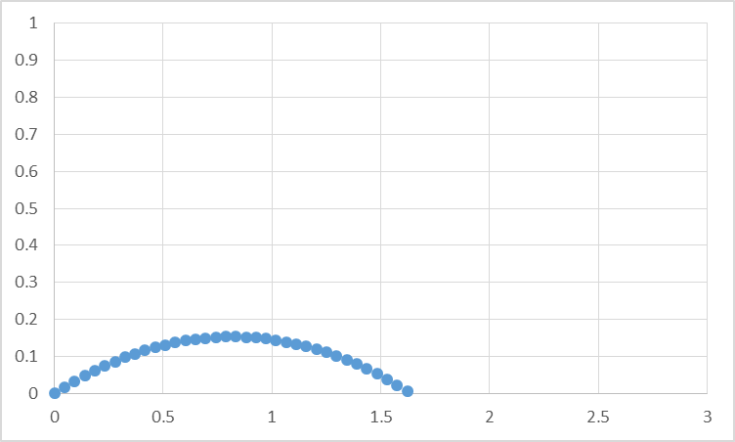If the launch angle was changed, the trajectory of the dice would have changed. The figures below were created as a visual representation of this change and produced using Excel.

Figure 12: The theoretical trajectory if the launch angle was 20°.

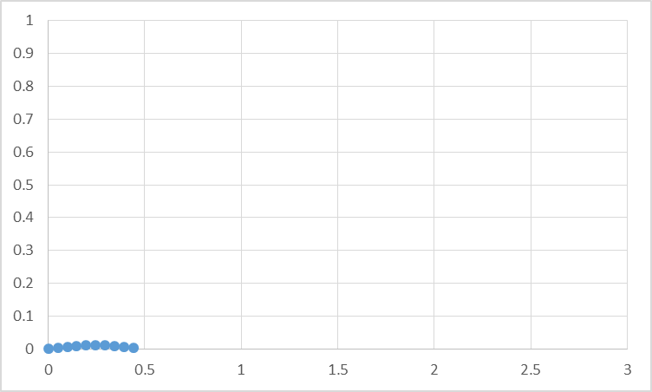Theoretically, the dice would have traveled the furthest if the launch angle was 45°. This was proved using equation (3). Sin(2×45) equals sin(90). Sin(90) equals one. If the launch angle was any other number, the range would have decreased since the equation would have eventually needed to be multiplied by a number less than zero. Therefore, a launch angle of 45° would have made the dice travel the farthest.

Figure 11: The theoretical trajectory if the launch angle was 5°.

# Conclusions

The results obtained from this project support the original theories of projective motion. These theories were the three main equations used to deal with projective motion – time, maximum height and range (equations (1), (2) and (3)). However, these three equations did not take into account any air resistance (drag) that acted on the dice during the motion. Therefore the values obtained were different compared to the experimental values (+0.24m and +0.13m for hitting the one and two metre targets respectively). The construction of the catapult remained well under the $20.00 budget with $6.50 remaining. If the design needed to be improved further, one aspect that could be changed would definitely be the side braces. They started to bend when under a lot of pressure. Adding two more Popsicle sticks to each side would greatly strengthen the brace.

# References

The Physics Classroom. 2017. What is a Projectile? Retrieved April 29, 2017, from <http://www.physicsclassroom.com/Class/vectors/u3l2a.cfm>

ENGR101S1 – Assignment 3. 2017. *Assignment 3 Briefing Sheet*. Engineering Department. University of Canterbury.

Serway, R., Jewett, J., Wilson, K., and Wilson, A. 2013. *Physics Vol. 1*. South Melbourne. Victoria Cengage Learning Australia. Chapter 3. Page 61.

Serway, R., Jewett, J., Wilson, K., and Wilson, A. 2013. *Physics Vol. 1*. South Melbourne. Victoria Cengage Learning Australia. Chapter 3. Page 62.

Serway, R., Jewett, J., Wilson, K., and Wilson, A. 2013. *Physics Vol. 1*. South Melbourne. Victoria Cengage Learning Australia. Chapter 3. Page 60.

# Appendices

Table 2: The theoretical trajectory when the projectile hit the target one metre away. This was produced using Excel.

|  |  |  |
| --- | --- | --- |
| *g* = | 9.81 | m2/s |
| *Ɵ =* | 15 | degrees |
| *V0*= | 4.92999 | m/s |
| dt | 0.01 | sec |
|  |  |  |  |  |
| t | v in x | v in y | x distance | y distance |
| 0 | 4.762 | 1.275974 | 0 | 0 |
| 0.01 | 4.762 | 1.177874 | 0.04762 | 0.01276 |
| 0.02 | 4.762 | 1.079774 | 0.09524 | 0.024538 |
| 0.03 | 4.762 | 0.981674 | 0.14286 | 0.035336 |
| 0.04 | 4.762 | 0.883574 | 0.19048 | 0.045153 |
| 0.05 | 4.762 | 0.785474 | 0.2381 | 0.053989 |
| 0.06 | 4.762 | 0.687374 | 0.28572 | 0.061843 |
| 0.07 | 4.762 | 0.589274 | 0.33334 | 0.068717 |
| 0.08 | 4.762 | 0.491174 | 0.38096 | 0.07461 |
| 0.09 | 4.762 | 0.393074 | 0.42858 | 0.079522 |
| 0.1 | 4.762 | 0.294974 | 0.4762 | 0.083452 |
| 0.11 | 4.762 | 0.196874 | 0.52382 | 0.086402 |
| 0.12 | 4.762 | 0.098774 | 0.57144 | 0.088371 |
| 0.13 | 4.762 | 0.000674 | 0.61906 | 0.089359 |
| 0.14 | 4.762 | -0.09743 | 0.66668 | 0.089365 |
| 0.15 | 4.762 | -0.19553 | 0.7143 | 0.088391 |
| 0.16 | 4.762 | -0.29363 | 0.76192 | 0.086436 |
| 0.17 | 4.762 | -0.39173 | 0.80954 | 0.0835 |
| 0.18 | 4.762 | -0.48983 | 0.85716 | 0.079582 |
| 0.19 | 4.762 | -0.58793 | 0.90478 | 0.074684 |
| 0.2 | 4.762 | -0.68603 | 0.9524 | 0.068805 |
| 0.21 | 4.762 | -0.78413 | 1.00002 | 0.061945 |
| 0.22 | 4.762 | -0.88223 | 1.04764 | 0.054103 |
| 0.23 | 4.762 | -0.98033 | 1.09526 | 0.045281 |
| 0.24 | 4.762 | -1.07843 | 1.14288 | 0.035478 |
| 0.25 | 4.762 | -1.17653 | 1.1905 | 0.024694 |
| 0.26 | 4.762 | -1.27463 | 1.23812 | 0.012928 |
| 0.27 | 4.762 | -1.37273 | 1.28574 | 0.000182 |
| 0.28 | 4.762 | -1.47083 | 1.33336 | -0.01355 |
| 0.29 | 4.762 | -1.56893 | 1.38098 | -0.02825 |
| 0.3 | 4.762 | -1.66703 | 1.4286 | -0.04394 |
| 0.31 | 4.762 | -1.76513 | 1.47622 | -0.06061 |
| 0.32 | 4.762 | -1.86323 | 1.52384 | -0.07826 |
| 0.33 | 4.762 | -1.96133 | 1.57146 | -0.0969 |
| 0.34 | 4.762 | -2.05943 | 1.61908 | -0.11651 |
| 0.35 | 4.762 | -2.15753 | 1.6667 | -0.1371 |

Table : The theoretical trajectory when the projectile hit the target two metres away. This was produced using Excel.

|  |  |  |
| --- | --- | --- |
| *Ɵ =* | 15 | degrees |
| *V0*= | 6.470476 | m2/s |
| dt | 0.01 | seconds |
| *g* = | 9.81 | m/s | | |
|  |  |  |  |  | |
| Time | V in x | V in y | X distance | y  distance | |
| 0 | 6.25 | 1.674682 | 0 | 0 | |
| 0.01 | 6.25 | 1.576582 | 0.0625 | 0.016747 | |
| 0.02 | 6.25 | 1.478482 | 0.125 | 0.032513 | |
| 0.03 | 6.25 | 1.380382 | 0.1875 | 0.047297 | |
| 0.04 | 6.25 | 1.282282 | 0.25 | 0.061101 | |
| 0.05 | 6.25 | 1.184182 | 0.3125 | 0.073924 | |
| 0.06 | 6.25 | 1.086082 | 0.375 | 0.085766 | |
| 0.07 | 6.25 | 0.987982 | 0.4375 | 0.096627 | |
| 0.08 | 6.25 | 0.889882 | 0.5 | 0.106507 | |
| 0.09 | 6.25 | 0.791782 | 0.5625 | 0.115405 | |
| 0.1 | 6.25 | 0.693682 | 0.625 | 0.123323 | |
| 0.11 | 6.25 | 0.595582 | 0.6875 | 0.13026 | |
| 0.12 | 6.25 | 0.497482 | 0.75 | 0.136216 | |
| 0.13 | 6.25 | 0.399382 | 0.8125 | 0.141191 | |
| 0.14 | 6.25 | 0.301282 | 0.875 | 0.145185 | |
| 0.15 | 6.25 | 0.203182 | 0.9375 | 0.148197 | |
| 0.16 | 6.25 | 0.105082 | 1 | 0.150229 | |
| 0.17 | 6.25 | 0.006982 | 1.0625 | 0.15128 | |
| 0.18 | 6.25 | -0.09112 | 1.125 | 0.15135 | |
| 0.19 | 6.25 | -0.18922 | 1.1875 | 0.150439 | |
| 0.2 | 6.25 | -0.28732 | 1.25 | 0.148546 | |
| 0.21 | 6.25 | -0.38542 | 1.3125 | 0.145673 | |
| 0.22 | 6.25 | -0.48352 | 1.375 | 0.141819 | |
| 0.23 | 6.25 | -0.58162 | 1.4375 | 0.136984 | |
| 0.24 | 6.25 | -0.67972 | 1.5 | 0.131168 | |
| 0.25 | 6.25 | -0.77782 | 1.5625 | 0.124371 | |
| 0.26 | 6.25 | -0.87592 | 1.625 | 0.116592 | |
| 0.27 | 6.25 | -0.97402 | 1.6875 | 0.107833 | |
| 0.28 | 6.25 | -1.07212 | 1.75 | 0.098093 | |
| 0.29 | 6.25 | -1.17022 | 1.8125 | 0.087372 | |
| 0.3 | 6.25 | -1.26832 | 1.875 | 0.07567 | |
| 0.31 | 6.25 | -1.36642 | 1.9375 | 0.062987 | |
| 0.32 | 6.25 | -1.46452 | 2 | 0.049322 | |
| 0.33 | 6.25 | -1.56262 | 2.0625 | 0.034677 | |
| 0.34 | 6.25 | -1.66072 | 2.125 | 0.019051 | |
| 0.35 | 6.25 | -1.75882 | 2.1875 | 0.002444 | |
| 0.36 | 6.25 | -1.85692 | 2.25 | -0.01514 | |
| 0.37 | 6.25 | -1.95502 | 2.3125 | -0.03371 | |
| 0.38 | 6.25 | -2.05312 | 2.375 | -0.05326 | |
| 0.39 | 6.25 | -2.15122 | 2.4375 | -0.07379 | |
| 0.4 | 6.25 | -2.24932 | 2.5 | -0.09531 | |